- SQL Tasks
A1. Retrieve SPID, Amount and Boxes from sales.
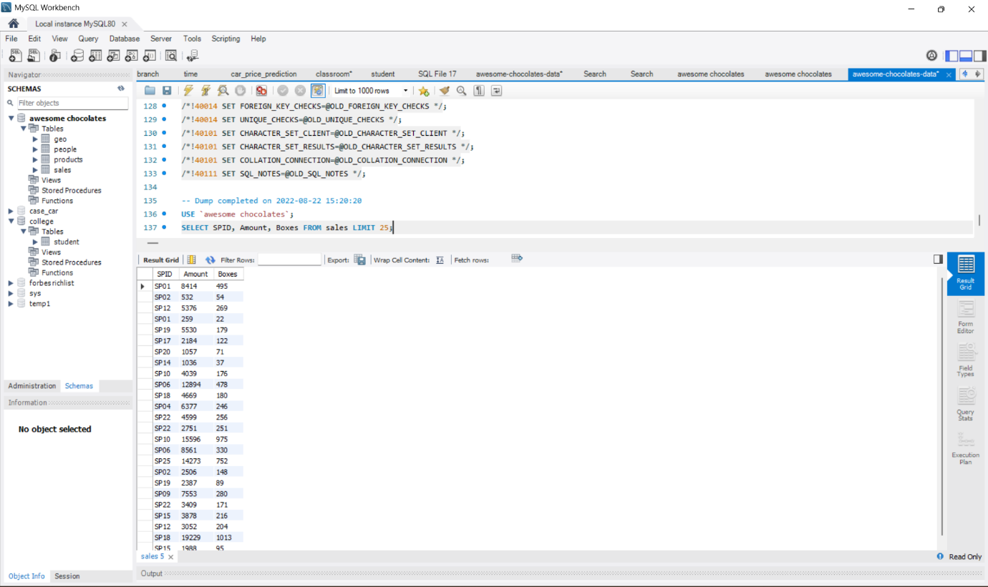

What we understood
This query helps us retrieve specific columns from the sales table instead of displaying all the data. It focuses only on important fields like salesperson ID, sales amount, and number of boxes sold.

Logic behind
The SELECT statement is used to choose specific columns from a table. By mentioning only SPID, Amount, and Boxes, the query filters out unnecessary data and returns only relevant information. This improves readability and efficiency.

A2. Retrieve sales where Amount > 10000.
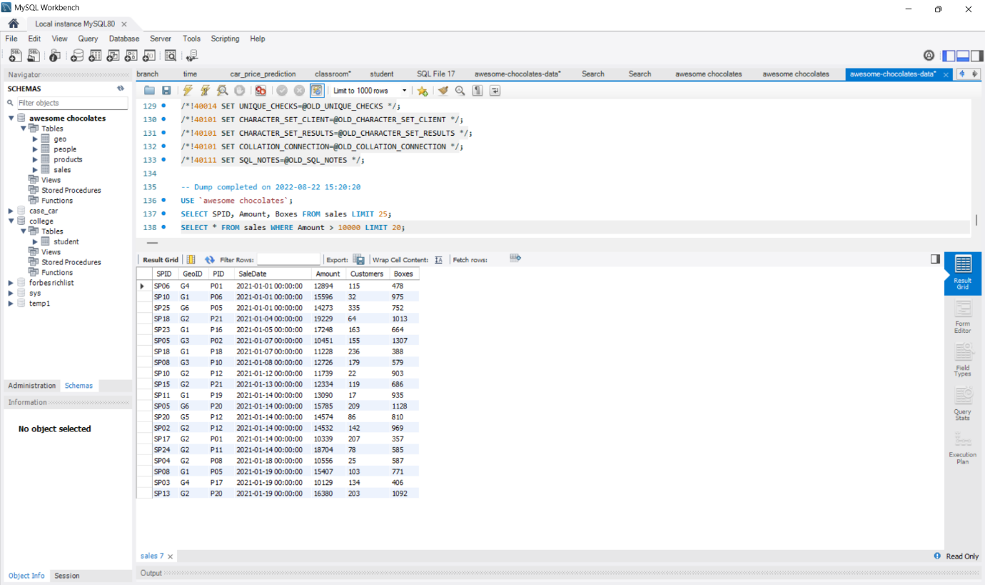

What we understood
This query helps us identify high-value sales transactions where the sales amount is greater than 10,000.
Logic behind
The WHERE clause is used to apply a condition on the data. Here, it filters rows where the Amount column is greater than 10,000. Only those records that satisfy this condition are returned.

A3. Retrieve sales where Amount > 5000 AND Boxes > 200.
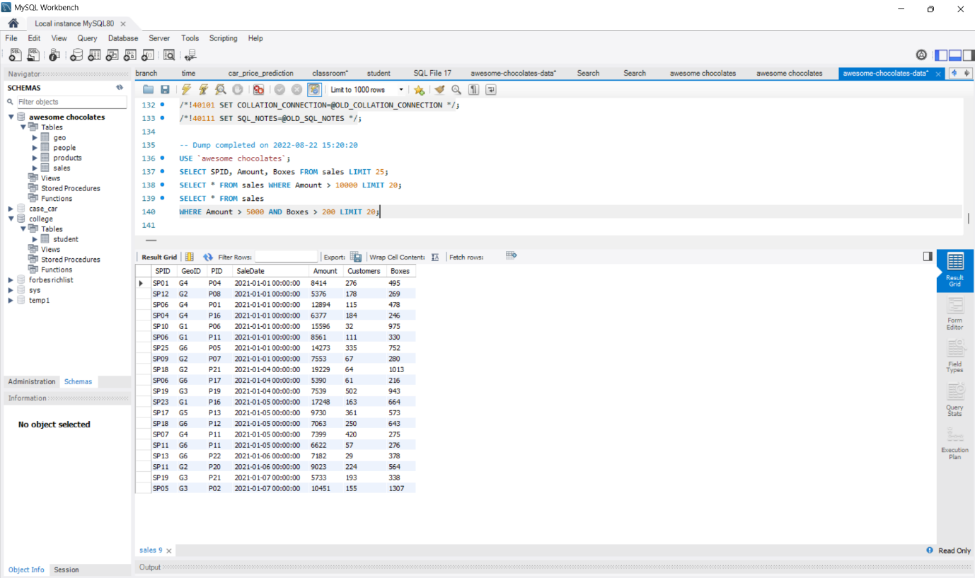
What we understood
This query helps us find sales where both the revenue and the number of boxes sold are high.
Logic behind
The AND operator is used to combine multiple conditions. The query returns only those rows where both conditions (Amount > 5000 and Boxes > 200) are true. If even one condition fails, the row is excluded.

A4. Retrieve sales where GeoID IN ('G1','G2','G3').
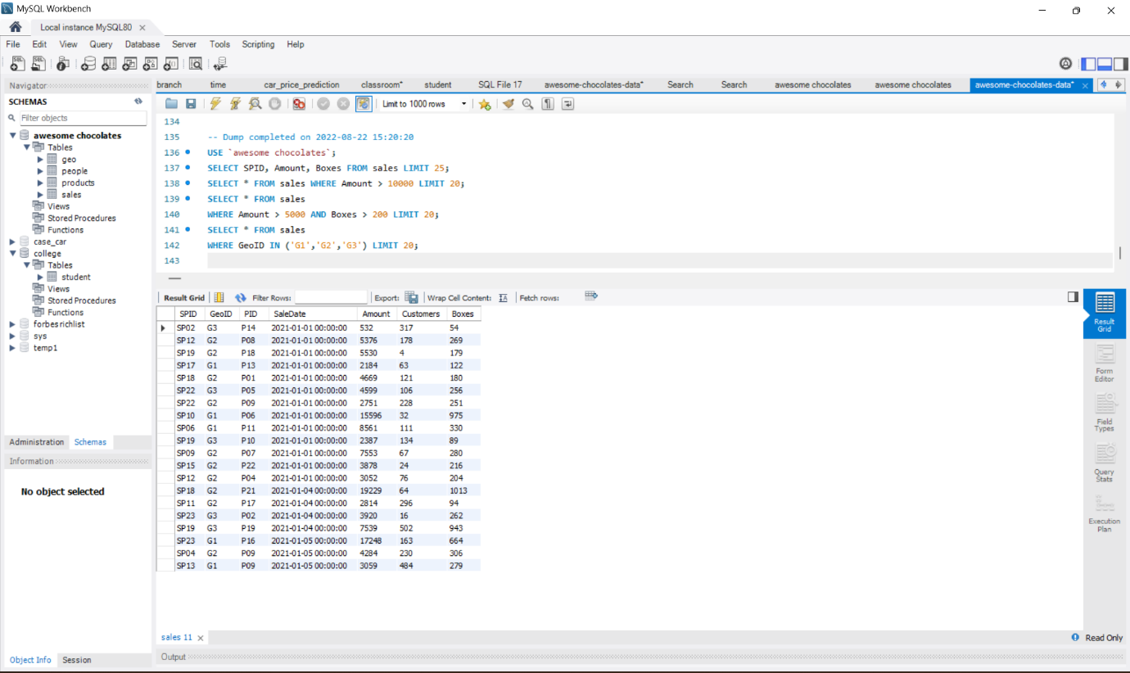

What we understood
This query filters sales data for specific regions or locations represented by GeoIDs G1, G2, and G3.
Logic behind
The IN operator is used to match multiple values in a column. Instead of writing multiple OR conditions, IN checks if the GeoID belongs to the given list. It simplifies the query and improves readability.

A5. Retrieve sales where GeoID NOT IN ('G4','G5').
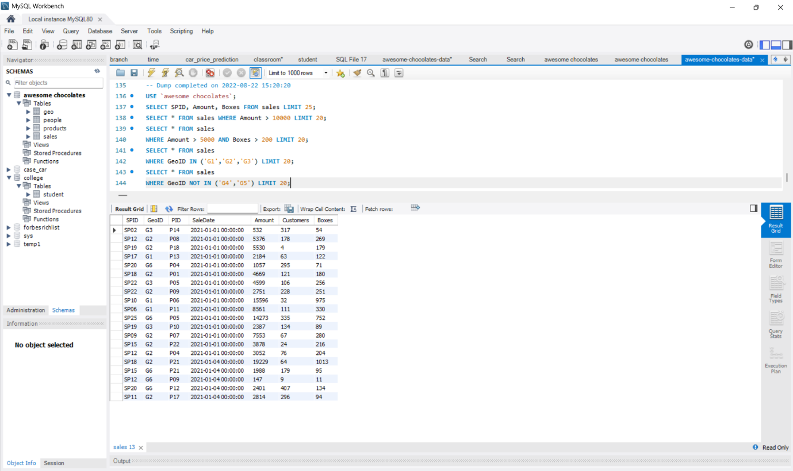
What we understood
This query helps us exclude certain regions (G4 and G5) and focus on the remaining locations.
Logic behind
The NOT IN operator is used to exclude specific values. It filters out rows where the GeoID is G4 or G5, and returns all other records. This is useful when we want to remove unwanted categories from the data.

- Python Tasks
B1. Task 1 – Variables
Store:
• Company name
• Employee name
• Salary
Print them in a formatted sentence.
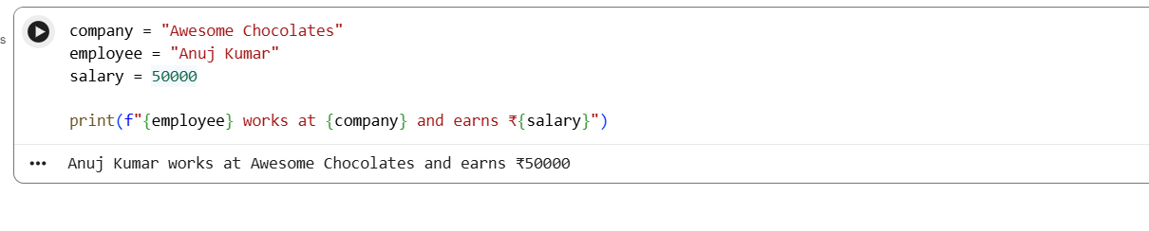
What we understood
We learned how to store data in variables and use them to create meaningful output.
Logic behind
- Variables store values (text or numbers)
- f-string combines variables into a sentence
- Makes output dynamic and readable

B2. Task 2 – Data Types
Create variables for:
• Integer (employee ID)
• Float (salary)
• String (department)
Print the datatype.
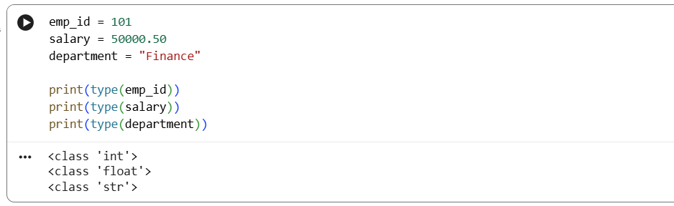
What we understood
We learned different types of data used in Python.
Logic behind
- int → whole numbers
- float → decimal values
- str → text
- type() function identifies datatype

B3. Task 3 – Operators
Ask the user for two numbers.
Find:
• Remainder
• Floor division
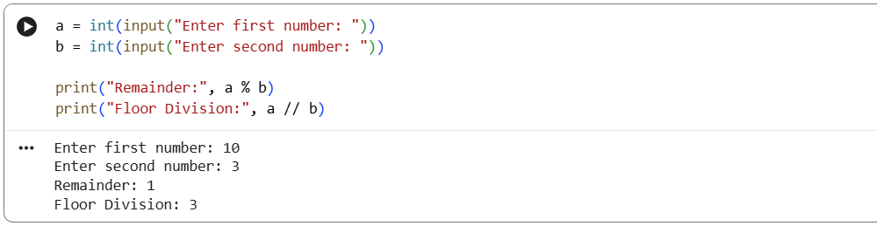
What we understood
We learned how to perform mathematical operations using operators.
Logic behind
- % → gives remainder
- // → gives integer division
- input() takes user input

B4. Task 4 – If / Else
Ask the user to enter a number.
Check whether it is:
• Even
• Odd
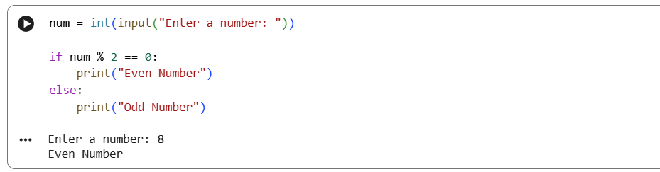
What we understood
We learned how to make decisions in code using conditions.
Logic behind
- % 2 == 0 checks divisibility
- If true → even
- Else → odd

Task 5 – Loop
Print even numbers from 1 to 20.
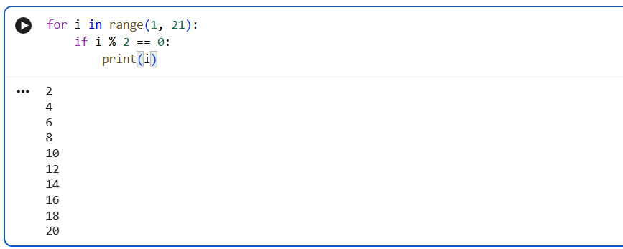
What we understood
We learned how to repeat tasks using loops.
Logic behind
- range(1,21) → numbers from 1 to 20
- Loop runs repeatedly
- Condition filters even numbers

